**Reason for Conditions**

*The following conditions are applied to:*

* *Confirm and clarify the terms of Council’s Approval;*
* *Identify minor modifications and additional requirements that will result in improved compliance, development and environmental outcomes; and*
* *Draw to the attention of the applicant and owner their responsibility to comply with the requirements of various legislation including but not limited to the Environmental Planning and Assessment Act, 1979, Local Government Act 1993; relevant Regulations; Building Code of Australia, Australian Standards and Local Policies relating to development works, building construction and protection and enhancement of public health and the environment.*

**APPROVED PLANS AND DOCUMENTATION**

1. The development shall be carried out in accordance with the stamped approved plans and documentation as detailed in the following schedule and any amendments arising through conditions to this consent or as shown in red colour on the plans:

|  |  |  |  |  |
| --- | --- | --- | --- | --- |
| **Plan Ref No.** | **Sheet**  **No.** | **Revn**  **No.** | **Revision**  **Date** | **Prepared by:**  **(consultant)** |
| *Architectural Plans* | | | | |
| Title Page  Site Analysis  Site Plan  Ground Floor Plan  Elevations | A000  A001  A004  A101  A200 | B | 4/09/2020 | Calderflower Architecture |
| Existing/Proposed Site  Demolition Plan  Height Plane Diagrams  Area Calculations  Site Analysis 02  Level 1 Floor Plan  Level 2 Floor Plan  Roof Plan  Sections  Shadow Diagrams  Materials | A002  A003  A005  A006  A007  A102  A103  A104  A210  A700  A800 | A | 16/06/2020 | Calderflower Architecture |
| Lower Ground Floor Plan | A100 | C | 4/9/2020 | Calderflower Architecture |
| Privacy Analysis No 44 Stronach Ave  Privacy Analysis for Erin Close  Privacy Analysis for Martin Close House | A1005  A1006  A1007 | A | 1/12/2020 | Calderflower Architecture |
| *Landscape Plans* | | | | |
| Overall Landscape Plan | L-SD-02 | B | 4/9/2020 | Arterra |
| Detail Landscape Plans and Signage  Landscape Calculations  Planting Strategy & Tree Plan  Entry Forecourt Section & Detail  Landscape Character Imagery | L-SD-03  L-SD-04  L-SD-05  L-SD-06  L-SD-07 | A | 12/6/2020 | Arterra |
| Privacy Analysis Sections – Stronach Ave  Privacy Analysis Sections – Erin Close  Privacy Analysis Sections – Martin Close | L-SD-10 | A | 4/9/2020 | Arterra |
| Maintenance Access Track Sections – 01, 02 & 03 | L-SD-13  L-SD-14  L-SD-15 | A | 30/10/220 | Arterra |
| Arboricultural Plans | T-01  T-02  T-03  T-04 | A | 12/6/2020 | Arterra |
| Riparian Definition & Offset Plan | RIP-01 | A | 15/6/2020 | Arterra |
| Typical Boundary Treatment – Erin Close Residents | - | - | 1/12/2020 | Arterra |
| Swale & Boundary Treatment Past Trees – Erin Close Residents | - | - | 1/12/2020 | Arterra |
| *Civil Engineering Plans* | | | | |
| Overall Site Plan  Civil Works – Sheet 1  Bulk Earthworks Plan  Bulk Earthworks Cut & Fill  Bulk Earthworks Sections | SW02  SW12  C01  C02  C03 | B | 12/6/2020 | Birzulis Associates |
| Overall Site Plan | SW02 | C | 18/6/2020 | Birzulis Associates |
| Soil Erosion & Sediment Control  Civil Works – Details Sheet 2 | SW11  SW13 | C | 3/9/2020 | Birzulis Associates |
| Soil Erosion & Sediment Control Plan | SW10 | D | 3/9/2020 | Birzulis Associates |
| Stormwater Drainage Concept Plan | C-GF-01  C-GF-02  C-GF-03  C-GF-04 | P2 | 13/10/2020 | Birzulis Associates |
| *Reports* | | | | |
| Statement of Environmental Effects | - | 2 | 18/6/2020 | Ethos Urban |
| Architectural Design Statement | - | - | June 2020 | Calderflower Architecture |
| Landscape Strategy | - | - | 16/6/2020 | Arterra |
| Traffic & Parking Assessment | - | V3 | 18/6/2020 | Ason Group |
| Operational and Construction Waste Management Brief | - | 1 | 15/6/2020 | Universal Food Design |
| Acoustic Assessment | - | 0 | 16/6/2020 | TTM Group |
| Accessibility Report | - | V3 | 18/6/2020 | Morris Goding Access Consultants |
| Bushfire Assessment Report | - | - | 19/6/2020 | Building Code & Bushfire Hazard Solutions |
| Bushfire Fuel Management Plan Proposal | - | - | 15/6/2020 | Fresh Hope Care |
| Arboricultural Impact Assessment Report | - | A | 11/6/2020 | Arterra |
| Biodiversity Assessment | - | V1.1 | 11/6/2020 | NGH Consulants |
| Operational Plan of Management | - | - | 15/6/2020 | Fresh Hope Care |
| Stormwater Management Plan | - | 2 | 18/6/2020 | Birzulis Associates |
| Preliminary Site Investigation | - | Final | 13/2/2020 | JK Environment |
| Detailed Site Investigation | - | Final | 30/3/2020 | JK Environment |
| Geotechnical Investigation & Groundwater Investigation | - | - | June 2020 | STS Geotechnical |
| Visual Impact Assessment | - | V1 | 18/6/2020 | Ethos Urban |
| Social Impact Assessment | - | 1 | June 2020 | Ethos Urban |
| Kitchen Operational Brief | - | 4.0 | 18/6/2020 | Universal Food Design |
| Laundry Operational Brief | - | 2.0 | 12/6/2020 | Universal Food Design |
| Food Services Design Compliance | - | - | 18/6/2020 | Universal Food Design |

**2**. The raised pathway between RL20.9 and emergency access point on the northern side of the building does not form part of this approval. **COMPLIANCE / LAND TITLE**

**3**. The Development shall comply with the provisions of the State Environmental Planning Policy (Housing for Seniors or People with a Disability) 2004.

Occupation of the Residential Care Facility shall be limited to *‘seniors*’ being people aged 55 years or more, or ‘*people with a disability*’ being people of any age who, as a result of an intellectual, physical, psychiatric or sensory impairment, either permanently or for an extended period, have substantially limited opportunities to enjoy a full or active life and people who live in the same household with seniors or people with a disability.

**4**. Prior to occupation of the development, a restriction as to user must be registered against the title of the property in accordance with Section 88E of the *Conveyancing Act 1919* limiting the use of any accommodation of the Residential Aged Care Facility as defined in the State Environmental Planning Policy (Housing for Seniors or People with a Disability) 2004.

A copy of the draft instrument shall be provided to Maitland City Council for review and approval prior to its registration.

**5**. **Prior to the issue of an Occupation Certificate**, the applicant shall submit evidence that a plan of consolidation of Lot 57 DP 260833 & Lot 5 DP 258655 has been registered with NSW Land Registry Services.

**6**.

The applicant shall prepare and submit to Council for approval a Plan of Management for the Asset Protection Zone (APZ) over the reserve area (Lot 3 DP 258655, Lot 58 DP 260833, Lot 61 DP 262743 & Part of Lot 2060 DP 1045875) which shall:

1. Generally be in accordance with the Fresh Hope Care Bushfire Fuel Management Plan Proposal;
2. Permits the use of the reserve area as an APZ for the adjoining lands;
3. Specifies the permissible works and the relevant standards for APZ works;
4. Permits the granting of an easement for an APZ; and
5. Consistent with the standard Plan of Management being prepared by Maitland City Council for the reserve area.

**7**. **Prior to issue of a Construction Certificate** for thebuilding works nominated on the Architectural plans prepared by Calderflower Architecture detailed in Condition No 1, the Plan of Management as detailed in condition No 5 shall be in force.

1. **8**. **Prior to issue of an Occupation Certificate** the developer shall provide evidence to the certifying authority that an easement for an APZ in accordance with the Plan of Management over the reserve area has been created that: Benefits Lot 57 DP 260833 as the dominant tenement;
2. *Provides:*
3. *For access for the owners and operators of the RACF to access the Reserve Area for the carrying out of APZ maintenance works in accordance with the PoM;*
4. *That Council is the sole authority to release the easement;*

**9**. **Prior to issue of an Occupation Certificate** the developer shall provide evidence to the certifying authority that a positive covenant on Lot 57 DP 260833 in accordance with s88BA of the *Conveyancing Act 1919* that:

1. *Imposes an obligation on the RACF owner from time to time to maintain or repair the APZ within the easement to accord with the requirements of any relevant fire regulation and the PoM for the reserve area;*
2. *Names the Council as the party entitled to enforce the covenant;*
3. *Provides that in the event the above obligation is not carried out by the RACF owner from time to time, then the Council may carry out the work and recover its reasonable costs of so doing form the RACF owner from time to time; or alternatively*
4. *Provides for a payment of a performance bond to Council calculated on the basis of net present value of the costs of maintaining the APZ over the anticipated life of the development, that in the event the above obligation is not carried out by the RACF owner from time to time, then the Council may carry out the work and draw down its reasonable costs of so doing from the performance bond.*

**10**. The owner or operator of the Residential Aged Care Facility is responsible for the ongoing maintenance of the APZ in accordance with any relevant fire regulation and the Plan of Management for the APZ.

**CERTIFICATES**

**11**. The applicant shall submit to Council a “Notice of Commencement” form at least two (2) days prior to the commencement of construction works.

**12. Prior to the commencement of works** an application for a Construction Certificate shall be submitted to, and be approved by, the Accredited Certifier.

**13. Prior to the issue of an Occupation Certificate** all conditions of development consent shall be complied with.

**14. Prior to occupation** of the building an Occupation Certificate shall be issued by the Principal Certifying Authority.

**15. Prior to issue of the Construction Certificate**, a Compliance Certificate under Section 50 of the Hunter Water Act 1991 for this development, shall be submitted to the Accredited Certifier.

**LANDSCAPING**

**16**. **Prior to the issue of the Construction Certificate** for the building works, a revised Landscape Plan shall be submitted to Council for approval. The plan shall be in accordance with the approved plan as referenced in Condition 1, be prepared by a suitably qualified landscape architect and address the following matters:

1. Include the retention of trees identified as T232, T233 & T235 within the Arboricultural Impact Assessment Report prepared by Arterra, dated 11 June 2020;
2. Identify additional landscaping to provide a suitable vegetated buffer to 42 Stronach Avenue in the location of the deleted pathway between RL 20.9 and emergency access point on the northern side of the building.
3. Amended landscape detail along the Erin Close boundary consistent with the stormwater drainage plan.

**17**. Landscaping shall be installed in accordance with the approved landscape plans **prior to the issue of an Occupation Certificate.**

**18**. The development shall be undertaken in accordance with the recommendations of the Arboricultural Impact Assessment Report prepared by Arterra Consulting Arboriculture dated 11 June 2020.

All reasonable measures shall be undertaken to protect existing vegetation (not approved for removal under this consent) to ensure it is not damaged prior to or during construction works.

**19**. All landscaped areas of the development shall be maintained to a high standard in accordance with the approved landscape plan at all times. The landscaped areas shall be kept free of parked vehicles, stored goods, waste material, and the like.

**20**. Lighting should meet the minimum Australian and New Zealand standards and the requirements of State Environmental Planning Policy (Housing for Seniors or People with a Disability) 2004. Low intensity security and sensor lighting shall be provided to all shared pedestrian paths, parking areas and/or entries in accordance with AS1158 – Public Lighting Code for Streets, Car Park Areas and Pedestrian Areas.

The lighting must be designed, positioned and installed to include appropriate shielding and orientation so as not to give rise to obtrusive light, interfere with traffic safety or detract from the amenity of the surrounding area in accordance with AS 4282:1997 – Control of the Obtrusive Effects of Outdoor Lighting. The lights should be low glare, vandal resistant and free from obstructions and should ensure that there is no light spill or glare beyond the property boundary.

**CARPARKING**

**21**. Car parking for the development shall be provided in accordance with the approved plans, with a minimum allocation for the development of Fifty (50) spaces including two (2) accessible car space, one (1) drop off/pick up space and one ambulance bay.

**22**. All driveways, parking areas and vehicles turning areas shall be constructed with a segmental paver surface (on a concrete sub-base), or as reinforced concrete excluding the permeable paving surfaces as indicated on the Landscape Plans prepared by Arterra.

**23**. All parking bays shall be delineated with line-marking and/or signposting.

**TRAFFIC, FACILITIES AND DEVICES**

**24**. The emergency access track is to be setback 3m from the boundary of 44 Stronach Avenue. The full length of this access track is to be constructed of compacted gravel to the property boundary. The driveway crossing on the public footway verge shall be constructed in concrete in accordance with Council’s Manual of Engineering Standards, which include the retention of (or if damaged reconstruction as plain concrete of) any existing footpath, and with reference to Council’s information document “*Footway Crossings (Driveways)”.*

**25**. Use of the emergency access track is to be limited to emergency services vehicles and pedestrians. No maintenance, service or construction traffic is to utilise the access track identified as the Maintenance Access Track on the Overall Landscape Plan, prepared by Arterra, Rev B dated 4 September 2020.

**26**. All work required to be undertaken within a public road reserve must make separate application to, and gain approval by Council, under Section 138 of the Roads Act 1993.

**27**. Engineering construction plans must be prepared and designed by a suitably qualified professional, in accordance with approved plans/documents, Council’s Manual of Engineering Standards, Austroads Guide and Roads and Maritime Services (RMS) requirements.  The Roads Act Approval from Council should be applied for at the same time as any works/construction Certificate within the site to avoid delays at the end of the project.

The required road works to be designed and constructed are as follows:

**a )** Provide an accessible concrete footpath (1.5m wide) from the proposed development to the bus stop on southside of Stronach Avenue near Martin Close. The footpath to be located on the northside on Martin Close from the proposed development, and on the southside of Stronach Avenue. Access ramps to be included in the design and construction of the footpath to provide access across Martin Close near Stronach Avenue, and if required, at the vehicle access to the proposed development.

**b )** New access driveways to be constructed in accordance with Council’s Manual of Engineering Standards.

**c )** Accessible kerbside bus stop landing infrastructure to be constructed at the Stronach Avenue bus stop, southside of road, in accordance with Council’s Manual of Engineering Standards.

**d )** Provide internal footpaths from the proposed building development access to the footpath required on Martin Close

**e ).** Prior to issue of a Construction Certificate, a Construction Traffic Management Plan (CTMP) to minimise the impacts of construction vehicles on traffic efficiency and road safety within the vicinity is to be submitted and approved by Council prior to the issue of the Construction Certificate. Any requirements identified by the CTMP shall gain the appropriate Roads Act Approvals if impacting within the road reserve.

**Note:** The CTMP is to identify that any construction access over 42 Stronach Avenue is prohibited.

**f** )All works associated with the subject development shall be undertaken at full cost to the developer and at no cost to Council.

**VEHICLE ACCESS**

**28**. **Prior to commencement of construction** of the driveway crossing on the public footway verge, the works shall have been approved by Council.  An application form, *“Application to Construct Private Works on Footway”* shall be submitted to Council, together with the appropriate fee (for each driveway).

**29**. **Prior to issue of the Occupation Certificate** the driveways shall be constructed with an asphaltic concrete or reinforced concrete wearing surface, in accordance with the approved plans, Council’s Manual of Engineering Standards and AS2890.1:2004 Parking facilities Off-street car parking and AS2890.2:2002 Parking facilities Off-street commercial vehicle facilities.

**STORMWATER DRAINAGE**

30. Prior to issue of the relevant Construction Certificate, a detailed stormwater drainage plan shall be prepared and designed in accordance with Council’s Manual of Engineering Standards.

1. On-Site Detention (OSD) of stormwater that reduces post development discharges to pre-developed discharges for the 1, 10 and 100 year ARI critical storm events.

**Minimum storage** storage volume of 178m³for on-site detention (OSD) shall be provided generally in accordance with Stormwater drainage plans (Project No:191030 Dwg no:C-GF 1- 4 issue:P2 dated: Apr 2020) by BIRZULIS Associates.

1. *A major/minor system shall be provided to convey stormwater within and from upstream of the site., and*
2. an emergency overland flow path for major storm events, that is directed to the public drainage system, and
3. entrapment of gross pollutants, nutrients generated from the contributing ground-surface catchment areas, and
4. detailed pavement finished surface levels, to ensure stormwater runoff catchment and its direction into the detention system.

**31. Prior to issue of the Occupation Certificate**, the stormwater-control system shall be constructed in accordance with the approved stormwater drainage plan. A qualified engineer shall supply written certification to the PCA that the constructed system including detention volume and discharge rates achieve the consent requirements for detention.

**32. Prior to Occupation or Operation of the development,**a *Stormwater System Maintenance Procedure Plan* shall be prepared by an engineer, detailing a regular maintenance programme for pollution control devices, covering inspection, cleaning and waste disposal, a copy of which shall be supplied to the owner/operator.

**EROSION CONTROLS**

**33**. The property shall be protected against soil erosion, such that sediment is not carried from the construction site by the action of stormwater, wind or “vehicle tracking”.

**BUILDING CONSTRUCTION**

**34**. All building work shall be carried out in accordance with the provisions of the Building Code of Australia.

**35**. All excavations and backfilling shall be executed safely, in accordance with appropriate professional standards and shall be properly guarded and protected to prevent the works from being dangerous to life or property.

36. Unless otherwise approved by Council in writing, all general building work shall be carried out between the hours of:

a. 7.00am to 6.00pm Monday to Friday

b. 7.00am to 5.00pm Saturday

Any work performed on Sunday’s or Public Holidays that may cause offensive noise, as defined under the Protection of the Environment Operations Act, is prohibited. Minor works (such as hand sanding, painting, digging and the like) is permitted between the hours of 9.00am to 5.00pm. Power operated tools are not permitted to be used.

**SERVICES & EQUIPMENT**

**37**. Upon completion of the building BUT prior to its occupation, a Final Fire Safety Certificate with respect to each critical and essential fire safety measure installed in the building shall be submitted to Council. Such certificates shall be prepared in accordance with Division 4 of Part 9 of the Environmental Planning and Assessment Regulation, 2000.

**38**. A copy of the Fire Safety Schedule and Fire Safety Certificate shall be prominently displayed in the building in accordance with Division 4 of Part 9 of the Environmental Planning and Assessment Regulation 2000.

**39**. A Fire Safety Statement in respect of each required essential and/or critical fire safety measure installed within the building shall be submitted to Council and the NSW Fire Commissioner annually (or at a more frequent interval for supplementary statements).

Statements shall be prepared and issued in accordance with Division 5 of Part 9 of the Environmental Planning and Assessment Regulation, 2000. Note that monetary penalties may apply for failure to lodge a fire safety statement within the prescribed timeframe.

Statements to the NSW Fire Commissioner are to be submitted electronically to [afss@fire.nsw.gov.au](mailto:afss@fire.nsw.gov.au).

Standard forms and further information for lodging Fire Safety Statements may be downloaded from Councils website.

**SITE CONSIDERATIONS**

40. All excavated and/or filled areas are to be retained or battered and suitably drained so as to prevent any subsidence of the area and constructed so as to deny any flow of water into the building.

Where a retaining wall is planned for this purpose and such wall requires consent (refer to State Environmental Planning Policy -Exempt and Complying Development Codes, 2008) plans and specifications of the wall shall be approved by Council and/or an accredited certifier.

*Note: The submission of a separate Development Application is not required for a retaining wall associated with this approval and indicated on the approved plans.*

All proposed retaining walls, including any excavation, footings, drainage and backfill shall be contained within the property boundaries. Retaining walls and associated earthworks shall not impede or redirect the natural flow of surface water from adjoining properties in a manner that creates nuisance.

41. If an excavation extends below the level of the base of the footings of a building/structure on an adjoining allotment of land, the person causing the excavation to be made.

i) Must preserve and protect the building/structure from damage, and

ii) If necessary, must underpin and support the building/structure in an approved manner, and

iii) Must, at least 7 days before excavating below the level of the base of the footings of a building/structure on an adjoining allotment of land, give notice of intention to do so to the owner of the adjoining allotment of land and furnish particulars of the excavation to the owner of the building/structure being erected or demolished.

The owner of the adjoining allotment of land is not liable for any part of the cost of work carried out for the purposes of this condition, whether carried out on the allotment of land being excavated or on the adjoining allotment of land. (Includes a public road and any other public place).

**42**. Rubbish generated from the development is to be suitably contained on site at all times. No rubbish shall be stockpiled in a manner which facilitates the rubbish to be blown off site.

43. If the work:

i) is likely to cause pedestrian or vehicular traffic in a public place to be obstructed or rendered inconvenient, or

ii) involves the enclosure of a public place

a hoarding or fence must be erected between the work site and the public place.

If necessary, an awning is to be erected, sufficient to prevent any substance from, or in connection with, the work falling into the public place.

The work site must be kept lit between sunset and sunrise if it is likely to be hazardous to persons in the public place. Any such hoarding, fence or awning is to be removed when the work has been completed.

44. A sign must be erected in a prominent position on the work:

i) stating that unauthorised entry to work site is prohibited, and

ii) showing the name of the person in charge of the work site and a telephone number at which that person may be contacted during work hours.

Any such sign is to be removed when the work has been completed.

*Note: This condition does not apply to:*

*i) building work carried out inside an existing building, or*

***ii)*** *building work carried out on premises that are to be occupied continuously (both during and outside working hours) while the work is being carried out.*

**45**. Approved toilet facilities are to be provided, at or in the vicinity of the work site at the rate of one toilet for every 20 persons or part of 20 persons employed at the site. The provision of toilet facilities in accordance with this Clause must be completed before any other work is commenced.

**46**. The site is to be cleared of all building refuse and spoil immediately after completion of the building/structure.

**47**. No building materials, refuse or spoil is to be deposited on or be allowed to remain on Council's footpath.

**48**. Suitable and adequate measures are to be applied to restrict public access to the site and building works, materials and equipment.

**DEMOLITION**

**49**. **Prior to the commencement of demolition** a hazardous building materials survey of the existing structure is to be prepared and submitted to Council.

**50**. All demolition works are to be carried out in accordance with Australian Standard AS 2601-2001.

**51**. In the event of an undisclosed or unidentified contamination being found on-site or any potentially contaminating infrastructure (e.g. underground storage tanks) or soils (e.g. staining, odours, asbestos) being identified during works, a qualified and experienced consultant must inspect, review and advise on remediation or mitigation prior to further construction proceeding. Council must be notified if this occurs and must be provided with any resulting reports and recommendations.

**52**. Where any demolition, alteration or renovation works encounter asbestos or products containing asbestos, then the materials encountered shall be managed in accordance with the provisions of the NSW Work Cover Authority.

**53**. Demolition material shall be recycled as far as is practicable and any demolition waste disposed of only at an authorised landfill facility.

**54**. Suitable and adequate measures are to be applied to restrict public access to the site and building works, materials and equipment.

**55**. The site is to be cleared of all building refuse and spoil immediately after completion of the building/structure.

**56**. No building materials, refuse or spoil is to be deposited on or be allowed to remain on Council's footpath.

**57**. The applicant is required to notify Council in writing prior to commencing demolition works, of any existing damage to kerbing and guttering and/or footpath paving the absence of such notification shall signify that no damage exists and that the applicant will be liable for the cost of the reinstatement of any damage to kerbing and guttering or footpath paving which may be necessary after completion of the demolition works.

**ACOUSTIC / VIBRATION**

**58**. The development shall be undertaken in accordance with the requirements and recommendations of the Acoustic Assessment prepared by TTM dated 16 June 2020. Demonstrated compliance with acoustic measures is to be certified by an Accredited Acoustic Consultant and provided to the Principal Certifying Authority **Prior to issue of an Occupation Certificate.**

**59**. **Prior to release of Construction Certificate,** a Construction Noise Management Plan and Construction Vibration Management Plan shall be prepared in accordance with the recommendations of the Acoustic Assessment prepared by TTM dated 16 June 2020.

**60**. **Prior to the commencement of works** a dilapidation survey on the immediately adjoining properties shall be prepared by a suitably qualified structural engineer.

61. The use and occupation of the premises including all plant and equipment installed therein, shall not give rise to any offensive noise as defined under the Protection of the Environment Operations Act, 1997.

ENVIRONMENTAL HEALTH

62. The development will be required to comply with the requirements of The Food Act 2003, Food Regulation 2015, Food Standards Code and Australian Standard 4674 for the Design, Construction and Fit-out of Food Premises.

**63**. The Aged Care Kitchen will be required to be registered with the relevant Regulatory Authority (NSW Food Authority) **prior to the commencement of operations.**

64. Prior to the commencement of trade the café must be registered with Council and inspections will be incorporated into Council’s yearly inspections program. A fee will be chargedby Council in accordance with the fees and charges in this regard.

**65**. Any bucket traps, grease traps and associated sewer connections shall be installed in accordance with the requirements of Hunter Water Corporation.

**66**. If Council is nominated as the Principal Certifying Authority, details of compliance are to be included in the plans and specifications of the Construction Certificate. Where Council is not appointed the Principal Certifying Authority a Certificate from an appropriately qualified person confirming compliance with the relevant legislation and guidelines is to be provided to Council **prior to the issue of Occupation Certificate.**

**67**. To ensure compliance with the Local Government (General) Regulation 2005, the construction and operation of the premises to be carried out in accordance with the standards set out in Schedule 2, Part 2 Standards for Hairdressers. Fit out and operation should also take place in accordance with:

1. Guidelines for Construction & Operation of Hairdressing, Beauty & Skin Penetration Premises;
2. NSW Health Skin Penetration Guidelines;
3. Public Health Regulation 2012.

**68**. Any contaminated medical or pathological wastes stored on the premises shall be secured in approved containers and disposed of by a registered contractor in accordance with the requirements of the NSW Department of Health on a regular basis as detailed in the Waste Management Report.

**GENERAL TERMS OF APPROVAL**

**69**. The development shall comply with the General Terms of Approval dated 19 August 2020 issued by the NSW Rural Fire Service. A copy of the General Terms of Approval is provided as Attachment A to this schedule of conditions.

**70**. **Prior to issue of Occupation Certificate** the applicant shall submit to the Principal Certifying Authority, certification from a suitably qualified consultant that the development complies with the NSW Rural Fire Service General Terms of Approval.

**71**. The development shall comply with the General Terms of Approval issued by the Natural Resource Access Regulator (NRAR) dated 9 July 2020. A copy of the General Terms of Approval is provided as Attachment B to this schedule of conditions.

The attached GTA issued by NRAR do not constitute an approval under the *Water Management Act* 2000. The development consent holder must apply to NRAR for a Controlled Activity Approval after consent has been issued by Council **and before** the commencement of any work or activity.

**AUSGRID**

**72**. The development shall comply with the letter from Ausgrid dated 16 September 2020. A copy of this correspondence is provided as Attachment C to this schedule of conditions.

**ADVICES**

*The following advice is limited in scope and should not be understood to encompass all areas of responsibility of the consent holder, relating to the development.*

A You are advised that where underground works within the road reserve are required for necessary for supply of services (such as water, sewer, electricity, gas), further consent for a “*Road Opening*” must be obtained from Council.

Refer to Council’s form: “*Application for Registration to Open Roads/Footpaths”.*

**B** You are advised that in regard to potential soil erosion from the construction site, such pollution of the environment is an offence under the Protection of the Environment & Operations (POEO) Act and may incur infringement fines.

**C** You (or the owner) are advised to notify Council in writing, of any existing damage to the street infrastructure (including landscaping) along the frontage of the property, prior to commencement of construction. The absence of such notification signifies that no damage exists. Where necessary repairs are carried out by Council, the owner of the property shall be held liable for the cost of those repairs.

**D** You are advised that there may be design matters in relation to the drainage *concept* plan that warrant further attention prior to the issue of the Construction Certificate.

**E** You are advised that, prior to pouring of internal concrete driveways and kerbs, which act as surface depression storage for the stormwater detention, (and/or surfaces which divert runoff to those storage areas), levels should be confirmed, by survey, on formwork and control marks.

**F** You are advised that further consentfor a driveway across the footway verge must be obtained. *Inspections* of works (eg formwork & reinforcement MUST be carried out by Council. (See Council’s “Application *To Construct Private Works On Footway*”). You should contact Council (ph. 49 34 9700), giving at least 24 hours notice for inspections.

**G** You are advised that the issue of this development consent does not amount to a release, variation or modification by Council of any covenant or easement applicable to this property and that Council will not be held responsible when action on this consent results in any loss or damage by way of breach of matters relating to title of the property.

**H** You are advised that compliance with the requirements of the Disability Discrimination Act, (DDA) applies to works on this site. It should be noted that compliance with the Building Code of Australia does not necessarily meet the requirements of the DDA.

**ATTACHMENT A – NSW RURAL FIRE SERVICE GENERAL TERMS OF APPROVAL**

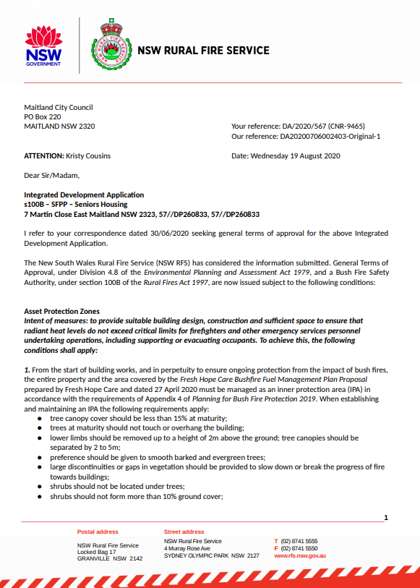

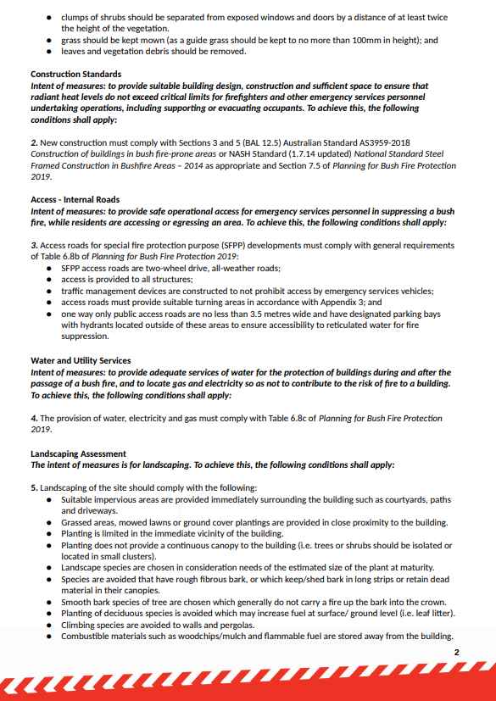

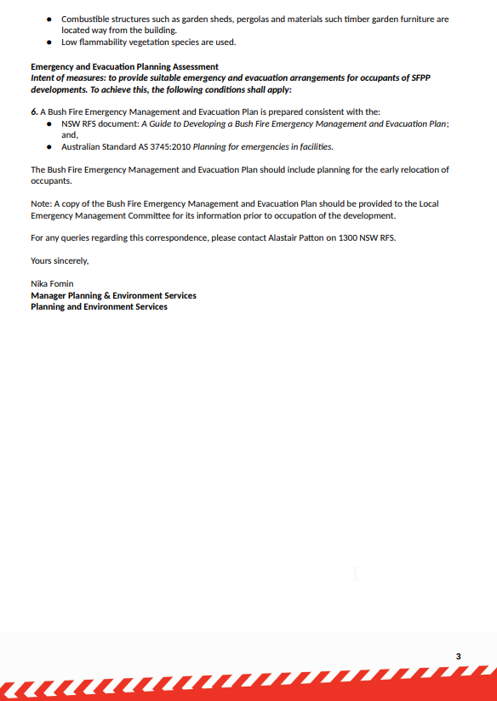

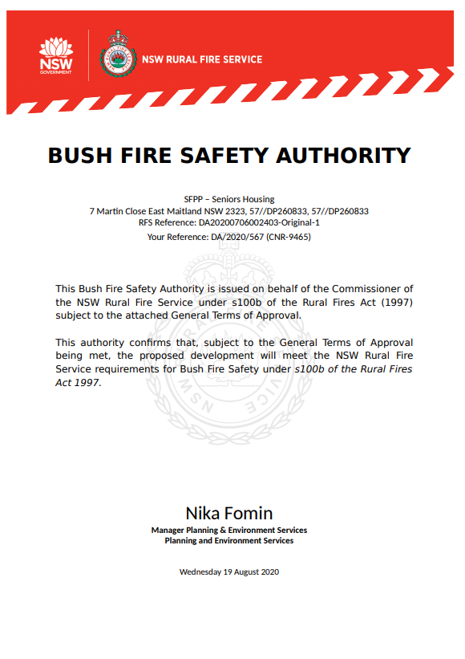

**ATTACHMENT B – NATURAL RESOURCES ACCESS REGULATOR GENERAL TERMS OF APPROVAL**

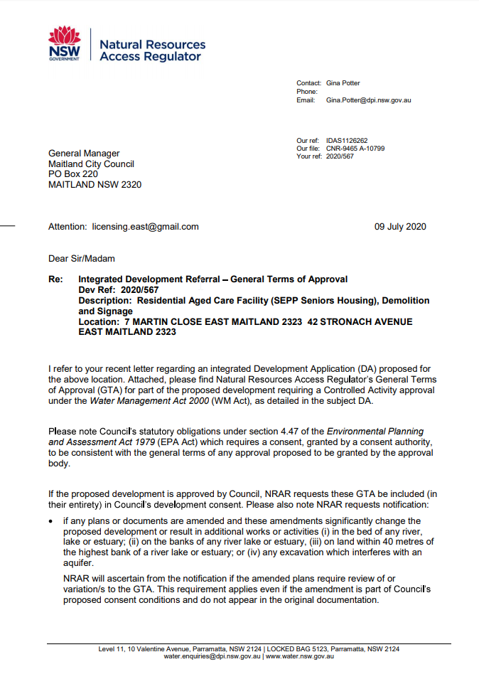

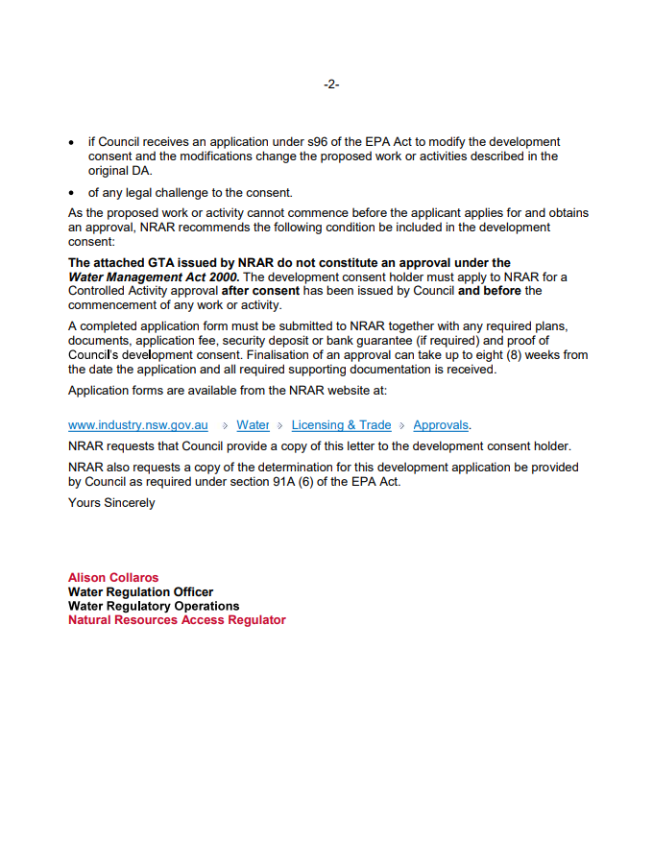 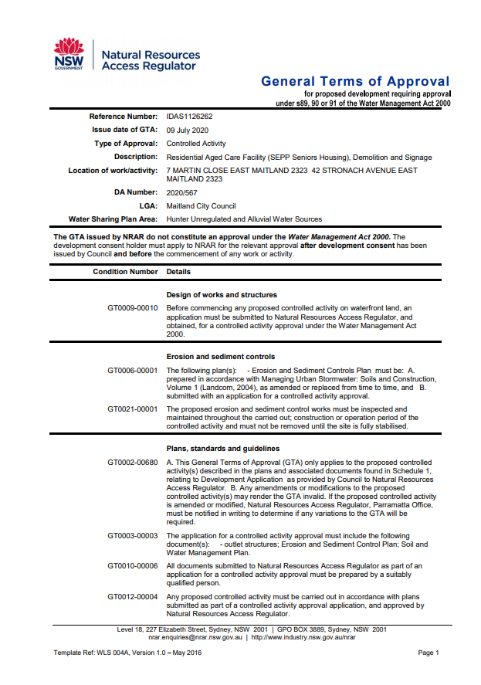

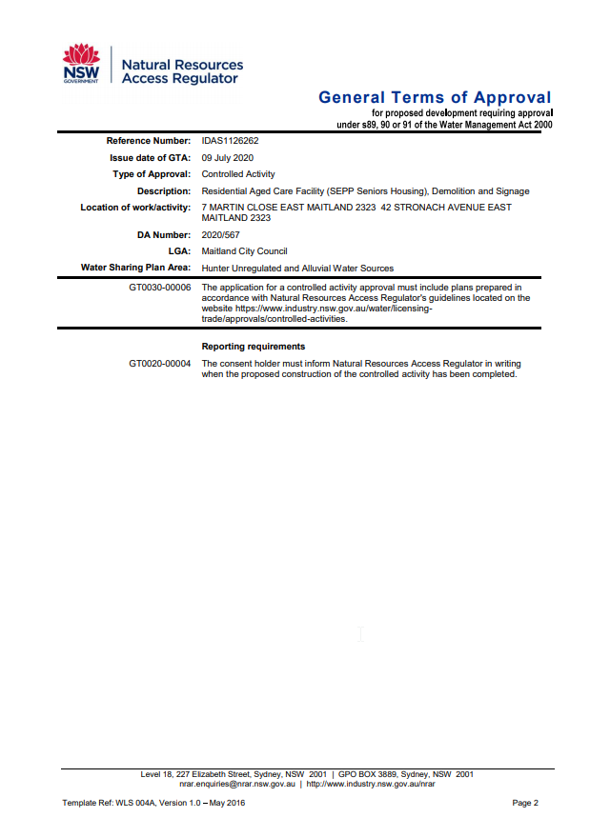

**ATTACHMENT C – AUSGRID CORRESPONDENCE IN ACCORDANCE WITH CLAUSE 45(2) OF THE SEPP (INFRASTRUCTURE) 2007.**

